

Project Name: Ground Booking System

Branch C-DAC Sept-2022

Documentation On

**“GROUND BOOKING SYSEM ”**

C-DAC SEPT 2022

**Guided By: Prathamesh Sir**

Submitted By :

**Group No: 28**

* **Mrunal Patil 200943020054**
* **Shahbaaz Shaikh 200943020084**
* **Jaywardhan Kumbhar 200943020044**
* **Amit Patted 200943020004**
* **Saqlain Kazi 200943020081**

**Table of Contents**

**1. Introduction 4**

1.1 Document Purpose **4**

1.2 Project Background **4**

1.3 Aim & Objectives **4**

**2. Business Requirements Overview**…………………………………………………………**5**

**3.Functional Requirements** **6**

3.1 Customer Module **6**

3.2 Owner Module **6**

3.3 Admin Module **6**

**4.** **Non-Functional Requirement………………………………………………………………7**

**5. Use Case Diagram 8**

5.1 Admin **9**

5.2 Customer **10**

5.3 Owner **11**

**6. Database Design 12**

1 Login **12**

2 Admin **12**

3 Owner…………………………………………………………………………………… **13**

4 Customer **13**

5 Ground **13**

6 Booking **13**

7 Sports **13**

8 Role **13**

9 Payment **14**

**7. E-R Diagram………………………………………………………………………………………14**

**8. Snapshots 15**

**9. Conclusion 20**

**List of Figures**

**Use Case Diagrams 17**

Fig 1 Admin 8

Fig 2 Customer 9

Fig 3 Owner 10

Fig 4 ER Diagram 14

1. **Introduction:**
   1. **Document Purpose:**

This document communicates the business requirements and scope for developing Ground Booking System. The scope of this document is to define the functional and non functional requirements, business rules and other constraints requirements.

## Project Background:

Sports have an immense impact on a person's daily life and health. They do not just give you an interesting routine but also a healthy body.

In Metropolitan Cities it’s very difficult to get the grounds/courts on our desired time. And many people are unaware of the location and the contact.

So here we have “Ground Booking System” anyone can book the ground/courts based on their desired locality and time slot easily from Our website.

## Aim & Objectives:

The main objective of this system is building a website which improves user accessibility and time flexibility to play sports no matter where they are located. Basically we are providing features like search sports venues, book sports venues, cancel sports venues, etc. The key benefits of ground booking system website is the user can find sports grounds as per his requirements any time at any moment. It provides all information and services of all

the sports venues. The ground booking system is enabled to manage the booking of the owners and customer.

1. **Business Requirements Overview:**

* Ground Booking System is the public web application

* Ground Booking System will be available in different cities.
* There are mainly two types of users. One is the Customer and other is the Owner.
* Customers can search for different grounds available and view their bookings.

* Owner can add different grounds for the user to view and also book grounds if required.
* Ground Booking System will be able to connect owner and customer efficiently.
* Ground Booking System will be maintained by Administrator.

# Functional Requirements Overview:

Ground Booking System consists of four modules described as below.

1. Customer Module
2. Owner Module
3. Admin Module

# **3.1 Customer** **Module**

* The Customer can register and login.
* The Customer can search and book the Sports venue.
* The Customer can view their bookings.
* The Customer can update and cancel the bookings.
* Customer will pay bill.
* Customer can give rating.

# **Owner Module**

* The owner can register and login.
* The owner can add , update ,remove the ground/court details.
* The owner can view the bookings.
* The owner can delete the account.

# **3.3 Admin Module**

* The admin can view user details
* The admin can view owner details
* The admin will authenticate the Customer and owner.
* The admin can remove customer and owner.

1. **Non-Functional Requirement:**

**4.1.1** **Performance Requirements**

The system should store all the database records of each user, owner and admin properly and the application should be available for use 24*7 through the server.

The application should be user friendly with a proper user interface which makes it easy for the user to understand. All the options should be present in properly accessible places for user convenience.

Admin staff personnel should be properly trained to operate the application so provided. user details, owner details and ground/courts details records are to be backed up securely across database servers. In case database is hacked by someone and data is deleted a backup server should be present for such purpose.

## *4.1.2 Safety Requirements*

All login ids and passwords of the Admin, User, Owner should be protected for privacy using whatever constraints required in the database or the application. The system requires the individual to acknowledge the person making use of the phone. Any adjustments like insert, erase, update, etc. for the data source can be integrated promptly as well as executed only by Admin. The admin can consider as well as alter any kind of information in this System.

* The website should use professional design, look and feel and color scheme.
* Users will have no limitations for accessing the application through Internet. The portal being an internet application, it is difficult specify exact number of visitor or users. Hence we will target the system to support between 5 and 10 million users on launch of phase 1.
* Being a public website, the site must follow general usability guidelines for menus, navigation, colors, links and other actions provided on the screens.
* The system should be designed in such a manner that user will be able to complete tasks in minimum number of steps.

## 5. Use-Case Diagram

**5.1 Admin:**

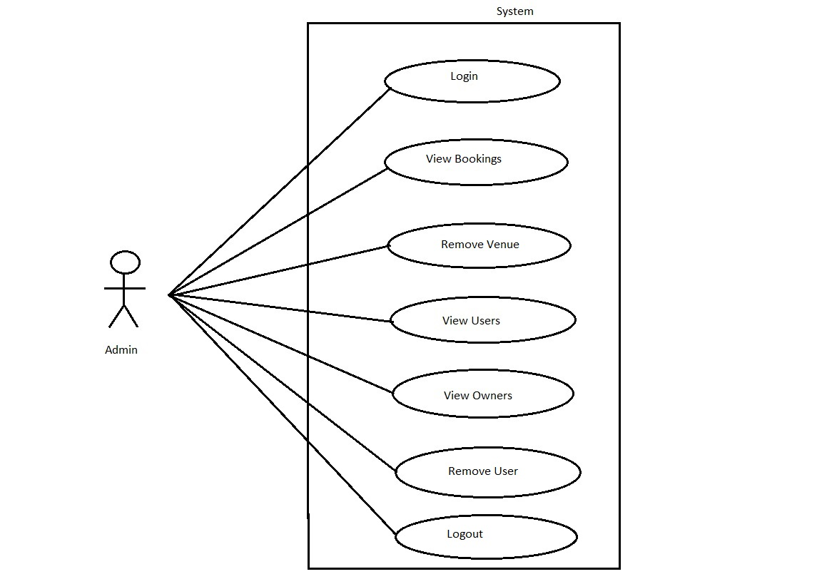

Fig. Use-Case Diagram for Admin

## 5.2 Customer:

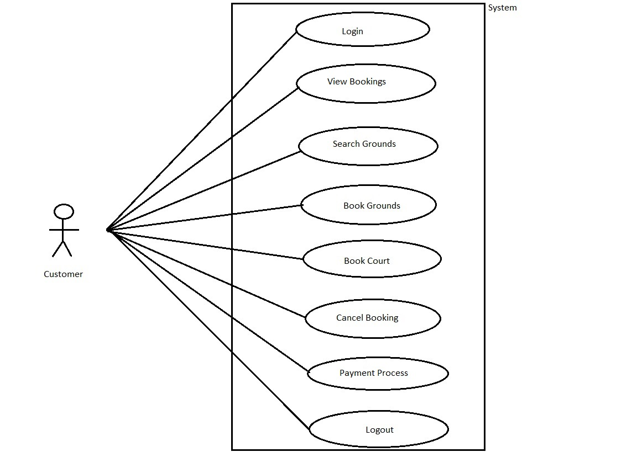

Fig. Use-Case Diagram for Customer

**5.3 Owner:**  
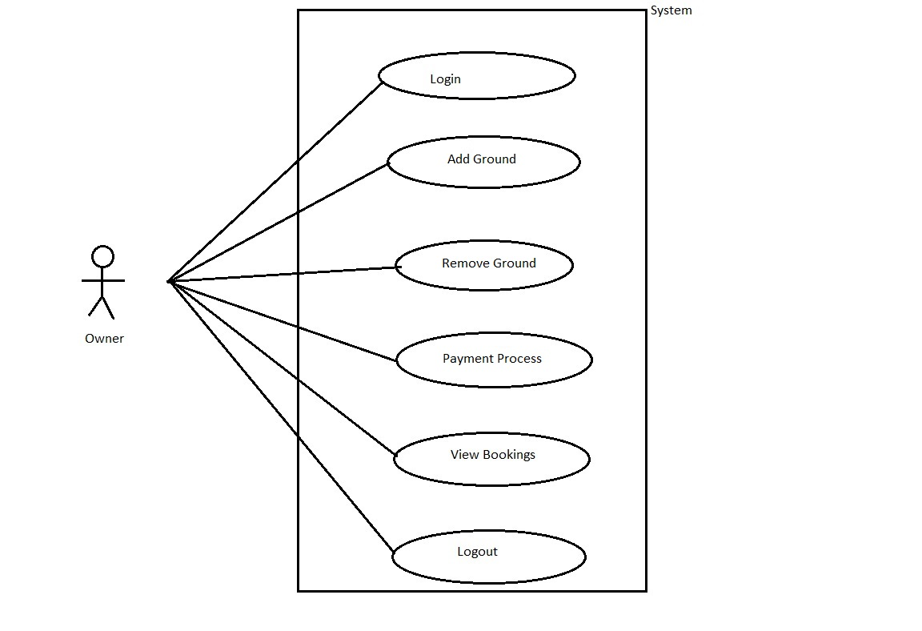

Fig. Use-Case Diagram for Owner

**6. Database Design:**

**1] user**

|  |  |  |  |  |  |
| --- | --- | --- | --- | --- | --- |
| **Field** | **Type** | **Null** | **Key** | **Default** | **Description** |
| userid | Integer | No | Primary key | Null | User ID |
| name | Varchar(45) | No |  | Null | User Name |
| password | Varchar(45) | No | Unique | Null | User Password |
| email | Varchar(45) | No | Unique | Null | Email ID Of user |
| Role_id | Integer | No |  | Null | Account type id |
| mobile | Integer | No |  | Null | Contact No. Of user |
| city | Varchar(100) | No |  | Null | User city |
| status | Varchar(100) | No |  | Null | User status |

**2] booking**

|  |  |  |  |  |  |
| --- | --- | --- | --- | --- | --- |
| **Field** | **Type** | **Null** | **Key** | **Default** | **Description** |
| booking_id | Integer | No | Primary key | Null | booking ID |
| amount | Varchar(45) | No |  | Null | Booking amount |
| date | Varchar(45) | No |  | Null | date |
| ground_id | Integer | No | Foreign key | Null | Ground id |
| Hall_id | Integer | No |  | Null | Hall id |
| Owner_id | Varchar(100) | No |  | Null | Ground owners id |
| Timeslot_id | Integer | No | Foreign key | Null | reference to timeslots (slotid) |
| grounddetails_groundid | Integer | No | Foreign key | Null | reference to ground_details (groundid) |
| Halldetails_hallid | Integer | No | Foreign key | Null | reference to Hall_details (o hallid id) |
| User_id | Integer | No | Foreign key | Null | reference to User (userid) |
| Timeslots_slot_id | Integer | No | Foreign key | Null | reference to Timeslots (slot_id) |

**3] timeslots**

|  |  |  |  |  |  |
| --- | --- | --- | --- | --- | --- |
| **Field** | **Type** | **Null** | **Key** | **Default** | **Description** |
| slotid | Integer | No | Primary key | Null | timeslots ID |
| ground_id | Integer | No | Foreign key | Null | reference to ground_details (groundid) |
| Hall_id | Integer | No | Foreign key | Null | reference to Hall_details (o hallid id) |
| timeslot | Varchar(45) | No |  | Null | Required timeslots |
| status | Varchar(45) |  |  |  | Booking status |

**4] ground details**

|  |  |  |  |  |  |
| --- | --- | --- | --- | --- | --- |
| **Field** | **Type** | **Null** | **Key** | **Default** | **Description** |
| Ground_id | Integer | No | Primary key | Null | Ground id |
| amount | Varchar(30) | No |  | Null | Booking amount |
| city | Varchar(45) | No |  | Null | Ground city |
| ground_image | Varchar(50) | No |  | Null | Ground image |
| Ground_name | Varchar(50) | No |  | Null | Ground name |
| location | Varchar(90) | No |  | Null | Ground location |
| ownerid | Integer | No | Foreign key | Null | reference to user(userid) |
| Sports_name | Varchar(50) | No |  | Null | Ground played sports |

**5] hall details**

|  |  |  |  |  |  |
| --- | --- | --- | --- | --- | --- |
| **Field** | **Type** | **Null** | **Key** | **Default** | **Description** |
| hall_id | Integer | No | Primary key | Null | hall id |
| amount | Varchar(30) | No |  | Null | Booking amount |
| city | Varchar(45) | No |  | Null | hall city |
| hall_image | Varchar(50) | No |  | Null | hall image |
| hall _name | Varchar(50) | No |  | Null | hall name |
| location | Varchar(90) | No |  | Null | hall location |
| ownerid | Integer | No | Foreign key | Null | reference to user(userid) |
| Sports_name | Varchar(50) | No |  | Null | hall played sports |

**5] ground details timeslot**

|  |  |  |  |  |  |
| --- | --- | --- | --- | --- | --- |
| **Field** | **Type** | **Null** | **Key** | **Default** | **Description** |
| Ground details_groundid | Integer | No |  | Null | reference to ground_details (groundid) |
| Timeslots_slot_id | Varchar(10) | No | unique | Null | reference to Timeslots (slot_id) |

**6] hall details timeslot**

|  |  |  |  |  |  |
| --- | --- | --- | --- | --- | --- |
| **Field** | **Type** | **Null** | **Key** | **Default** | **Description** |
| hall details_hallid | Integer | No |  | Null | reference to hall_details (hallid) |
| Timeslots_slot_id | Varchar(10) | No | unique | Null | reference to Timeslots (slot_id) |

**7] Tbl_Payment**

|  |  |  |  |  |  |
| --- | --- | --- | --- | --- | --- |
| **Field** | **Type** | **Null** | **Key** | **Default** | **Description** |
| tid | Integer | No | Primary key | Null | Transaction ID |
| SenderAccNo | Integer | No |  | Null | Sender Account Number |
| ReceiverAccNo | Integer | No |  | Null | Receiver Account Number |
| Amount | Double | No |  | Null | Amount To Be Transfer |
| DateTime | DateTime | No |  | Null | Date and Time OF Transaction |
| bookingid | Integer | No | Foreign key | Null | References to Booking (bid) |

## 7. ER-Diagram:

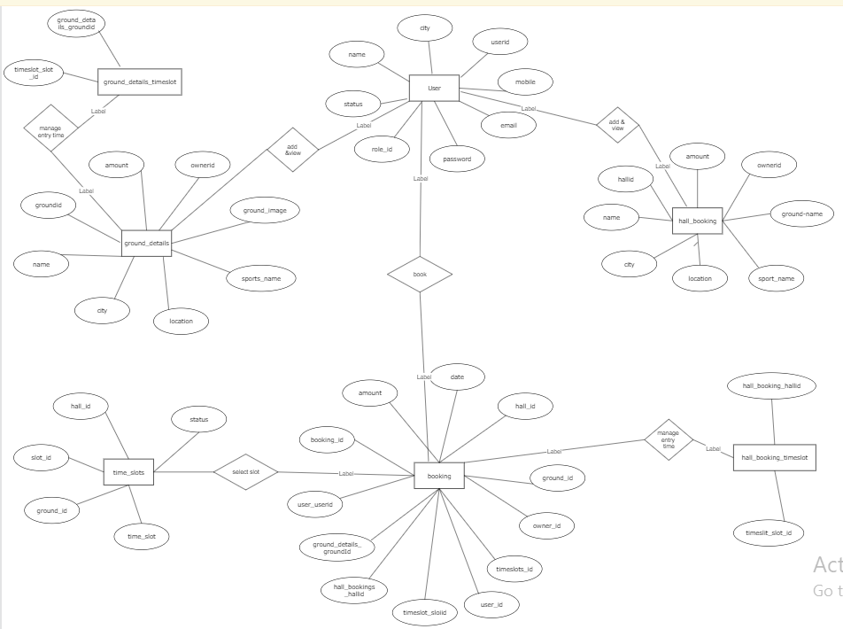

**E-R diagram shows database of Ground Booking System**

**8. Snapshots:**

**8.1 Home Page:**

Following snapshot shows the Home page for Ground Booking System.



This page contains following controls

* Home
* Contact
* About
* Login Button

**8.2 Contact Page**

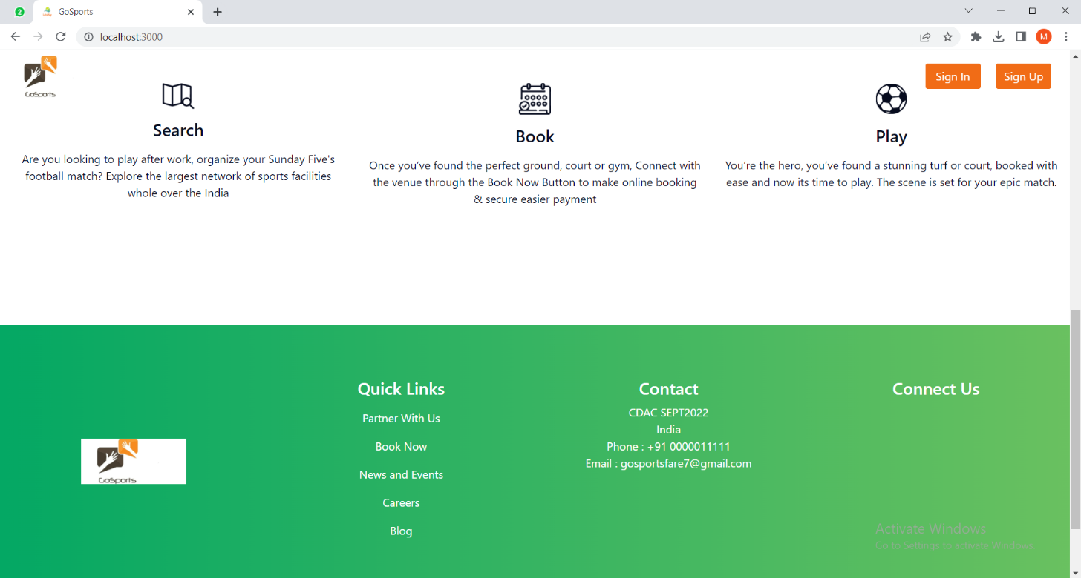

**8.3 About Page**

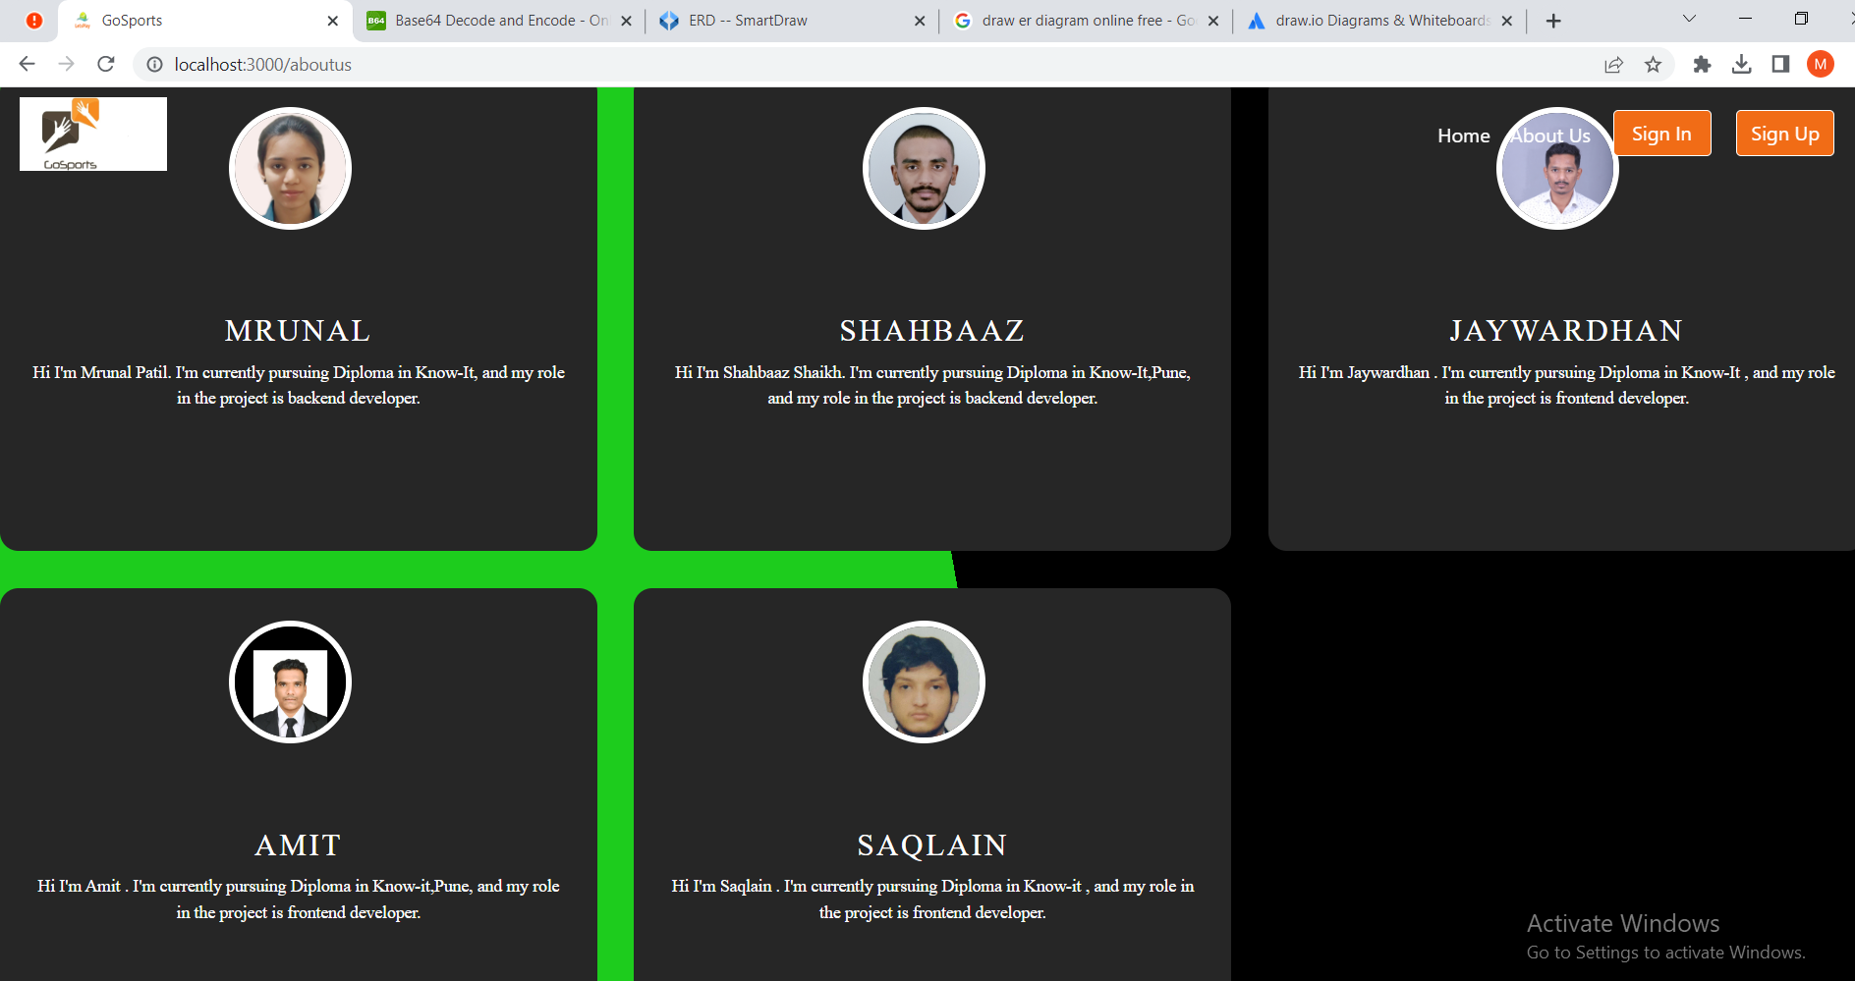

**8.4 Login Page**

Following snapshot shows the Login page for Ground Booking System

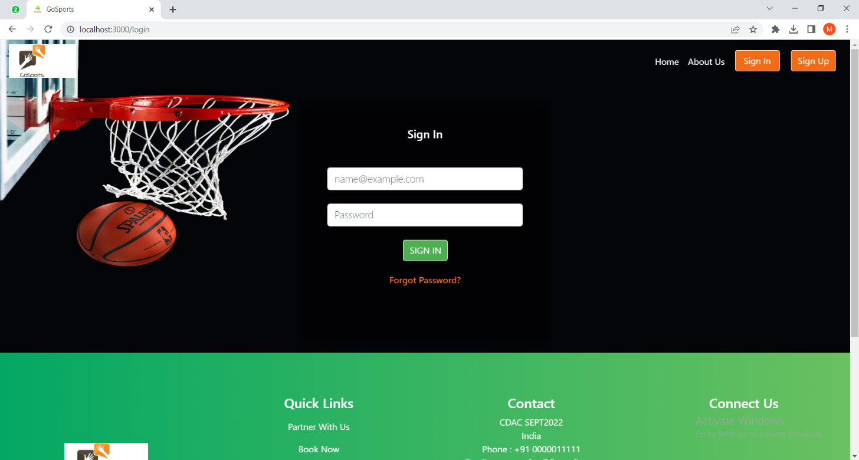

**8.5 Registration Page**

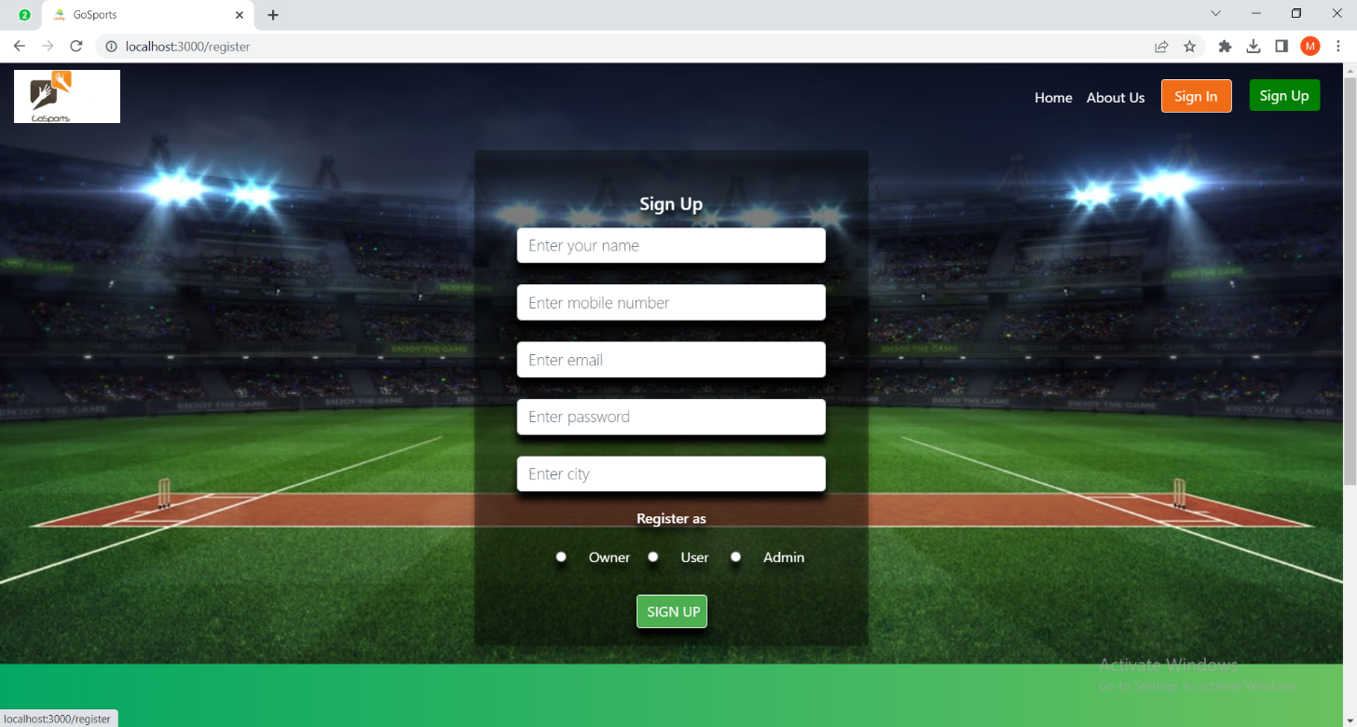

**8.5 Admin**

**8.5.1 Admin Home Page**

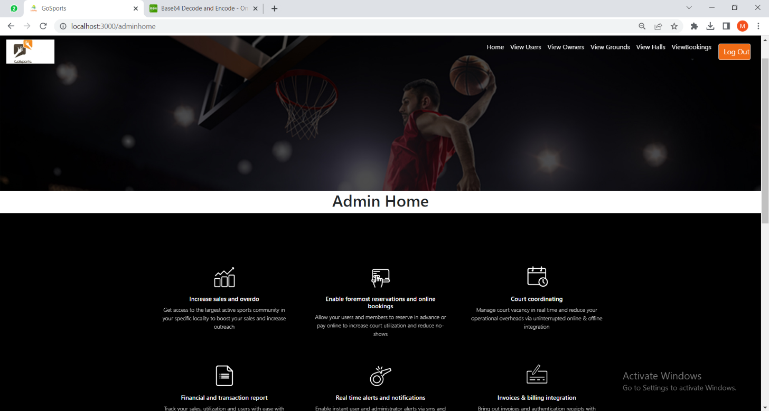

**8.5.2 All Customers List**

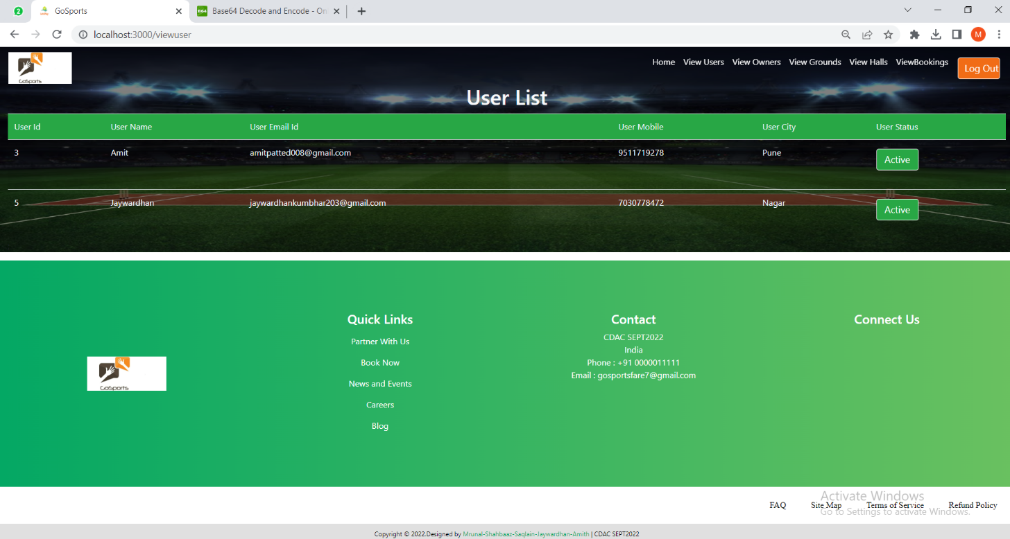

**8.5.3 All Owners List**

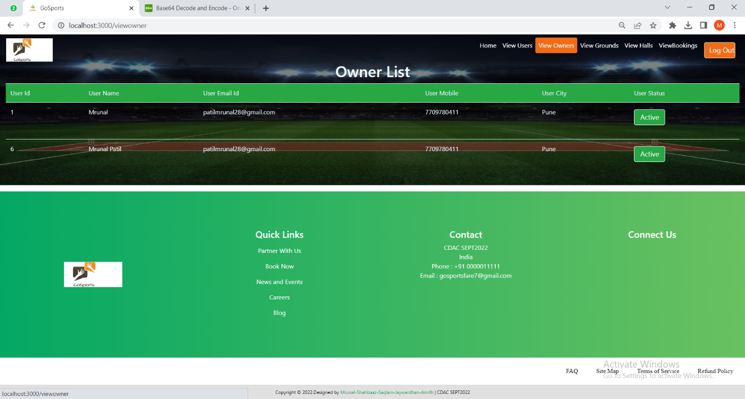

**8.5.4 All grounds added**

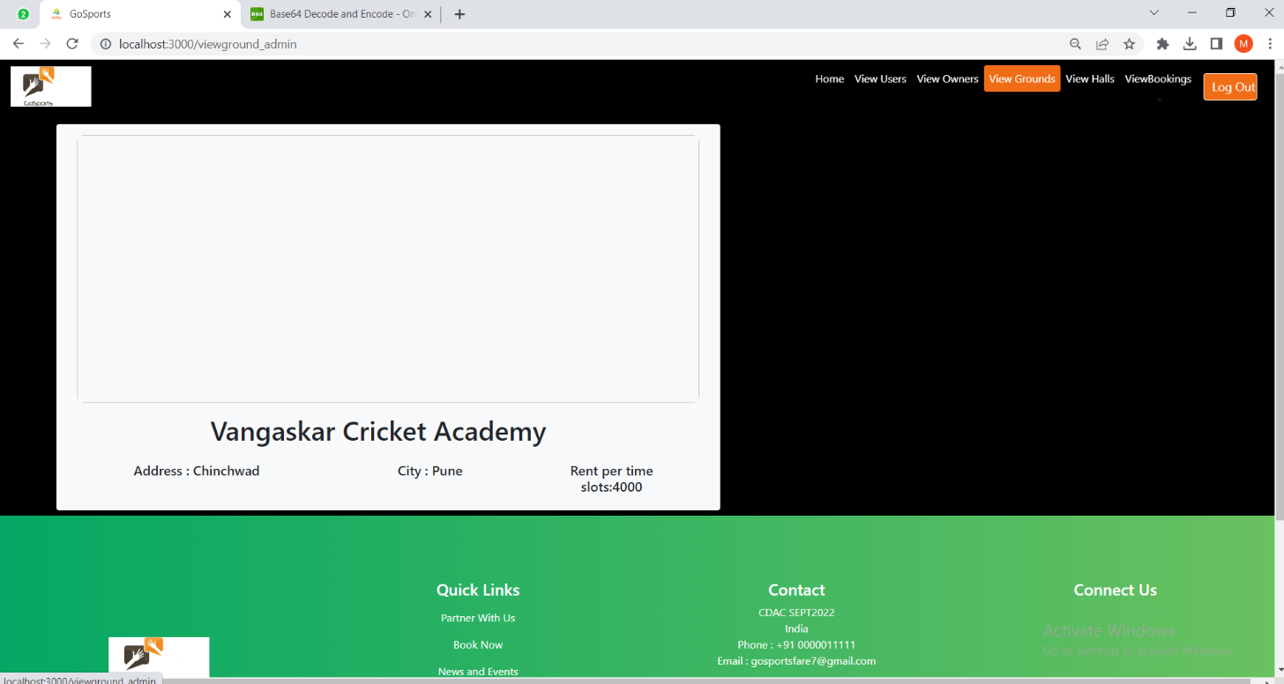

**8.5.5 All Bookings**

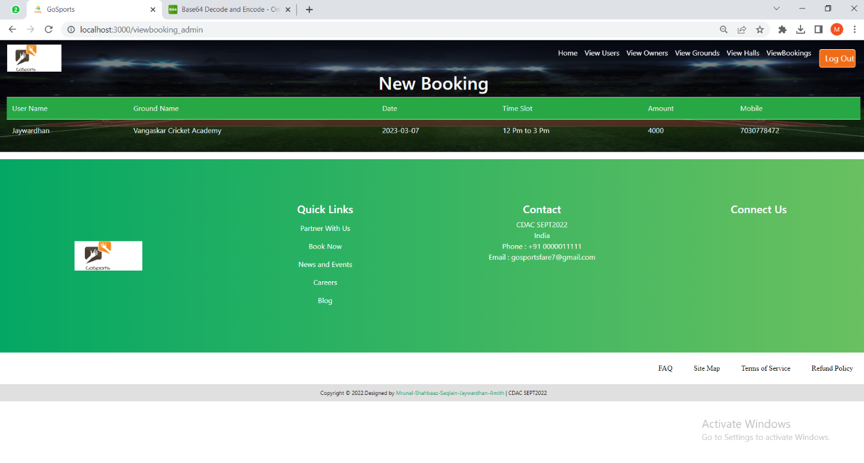

**8.6 Owner**

**8.6.1 Owner Home Page**

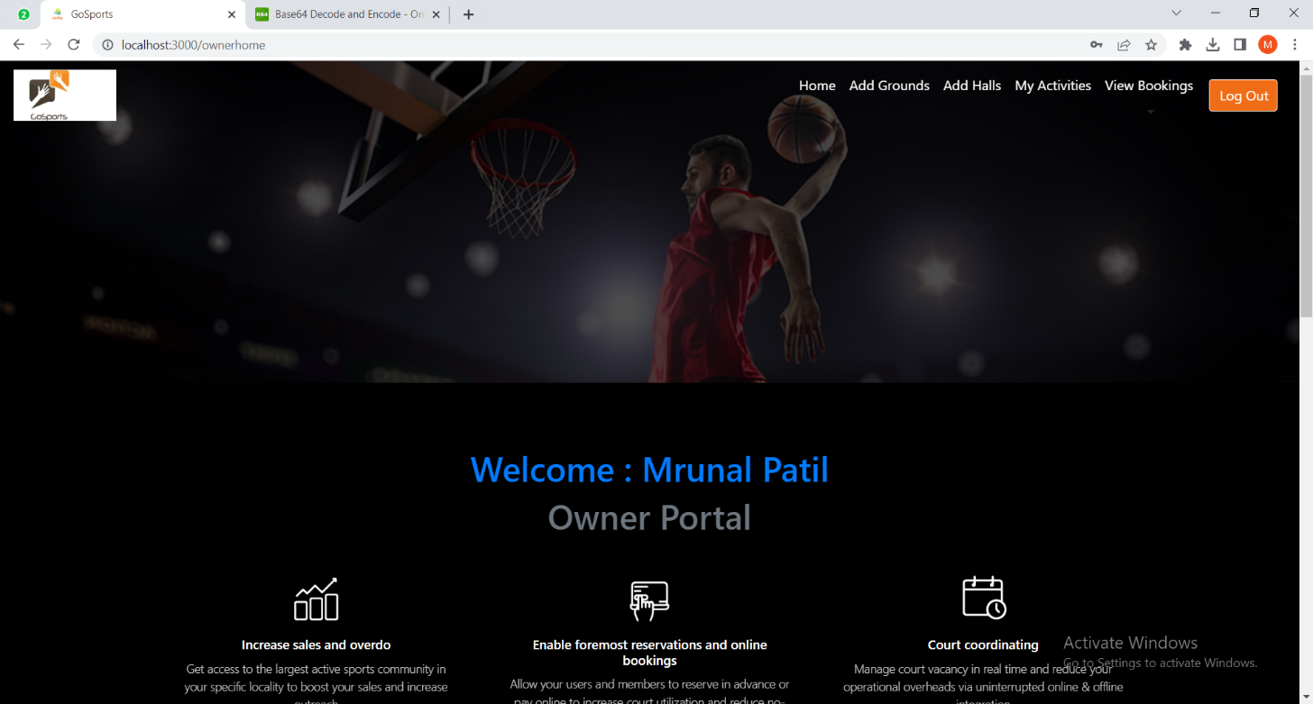

**8.6.2 Owner Add Ground**

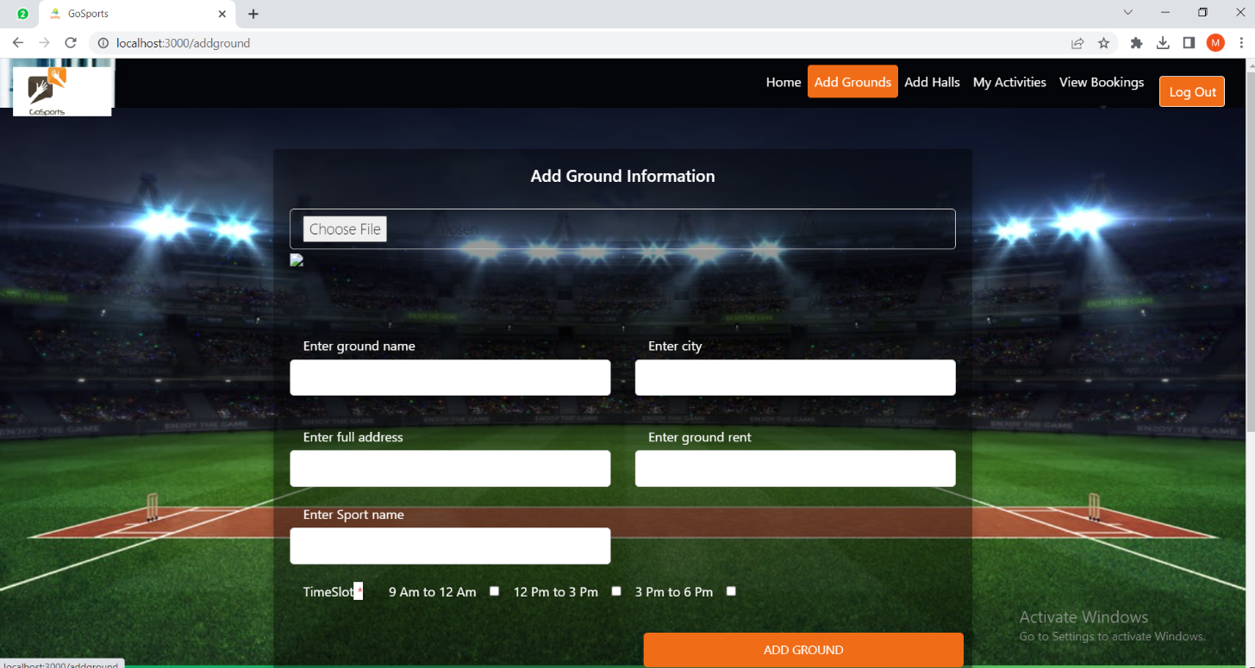

**8.6.3 Owner activities**

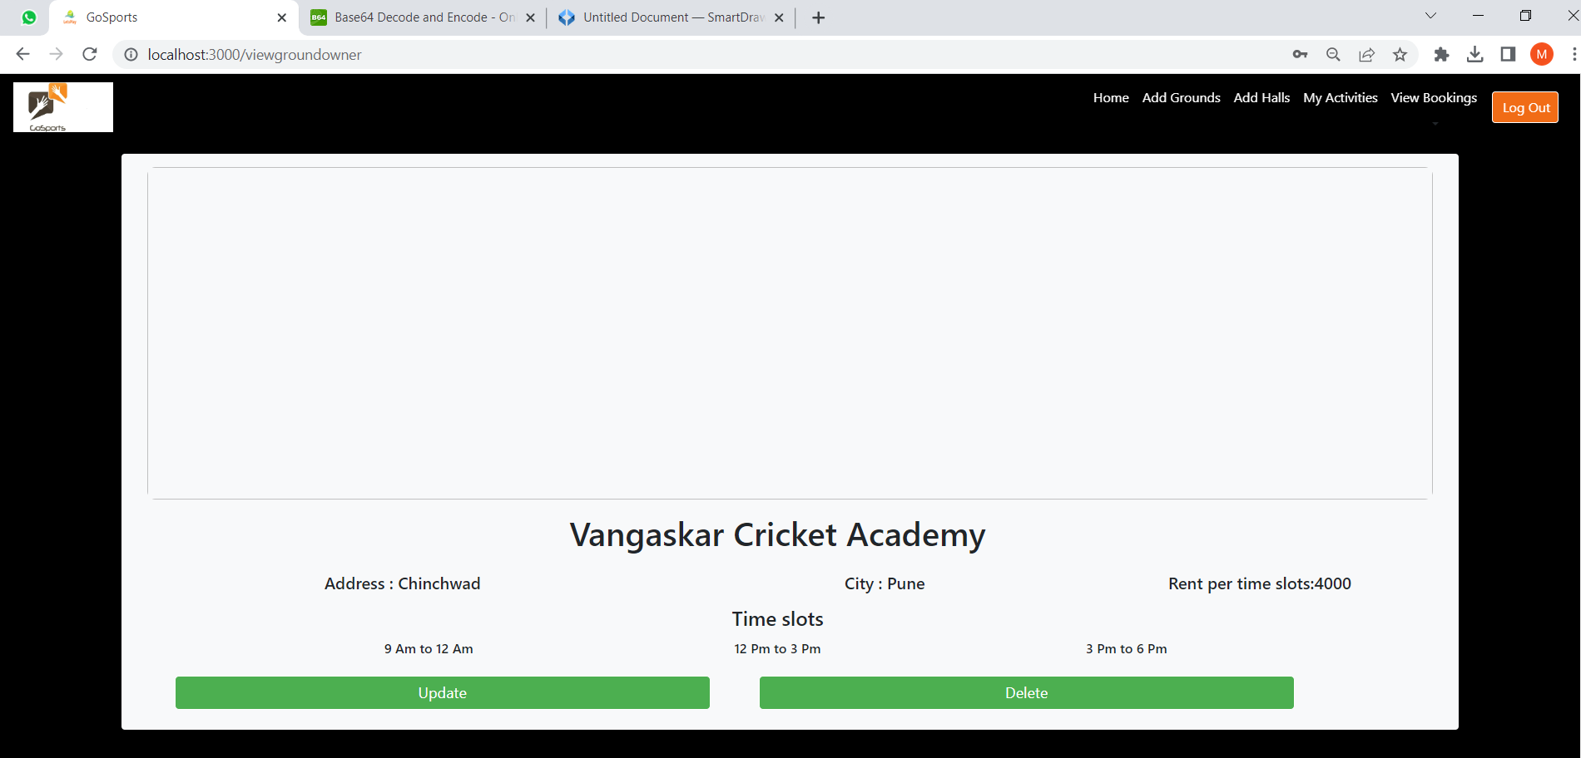

**8.6.3 Owner see bookings**

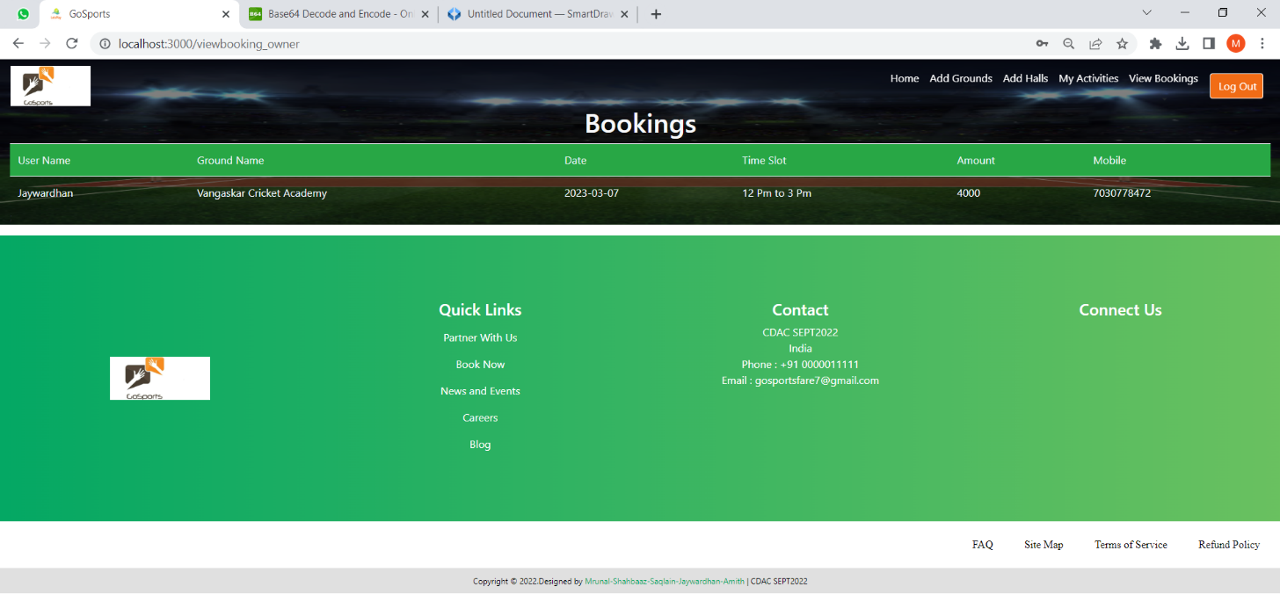

**8.7 Customer**

**8.7.1 Customer Home Page**

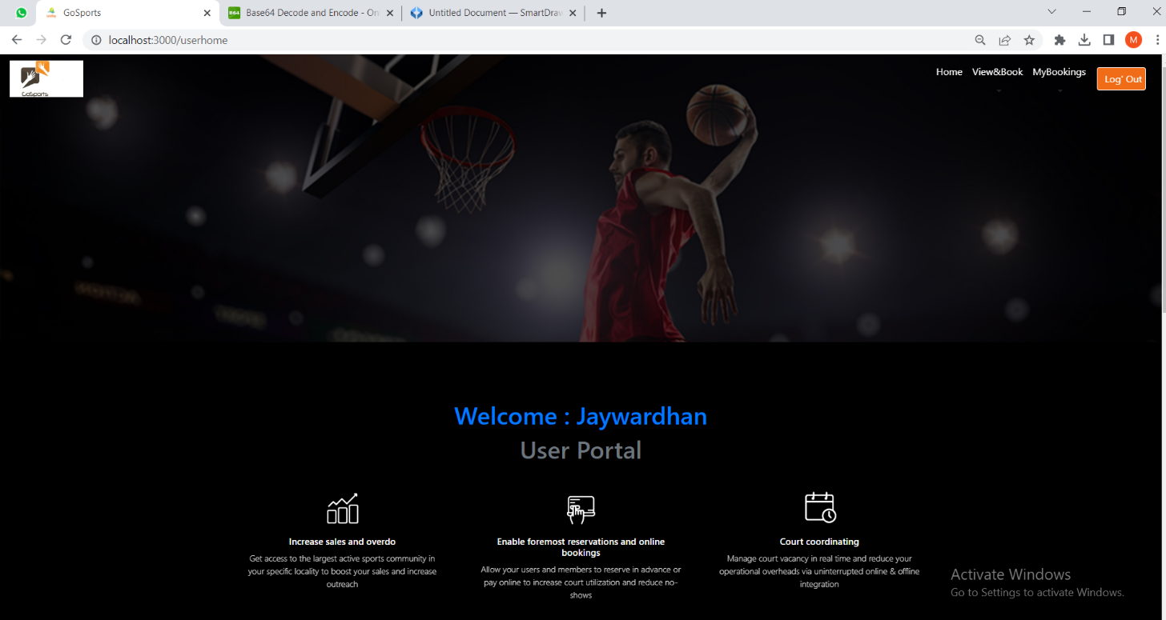

**8.7.2 Customer Book Ground**

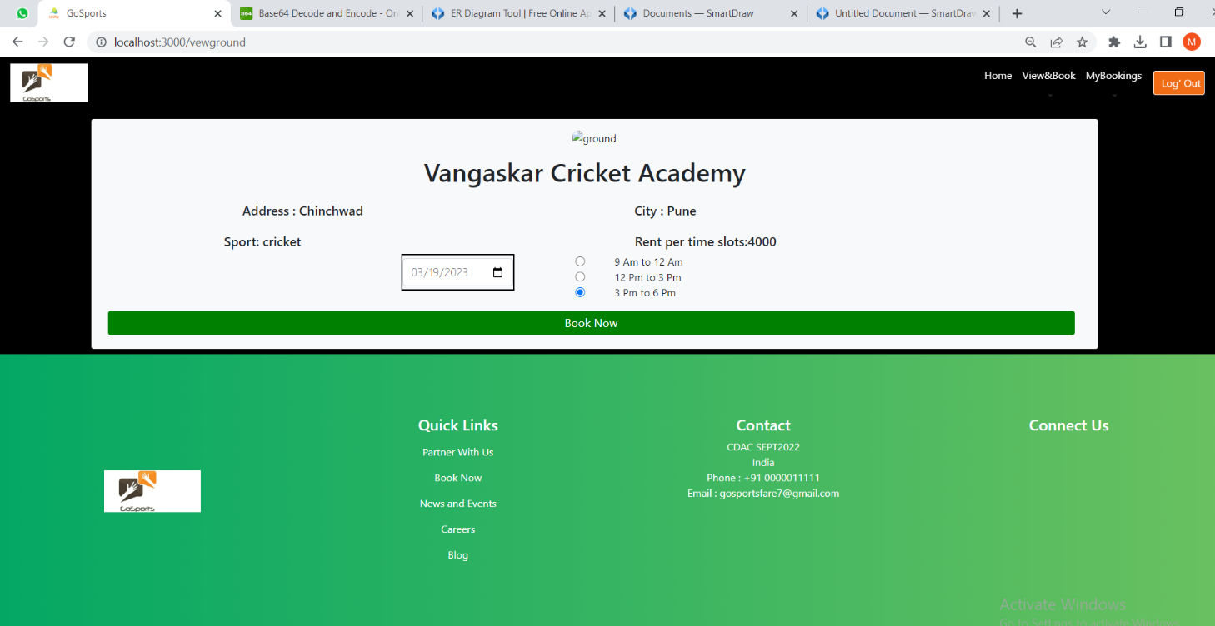

**8.7.3 Customer See Their Bookings**

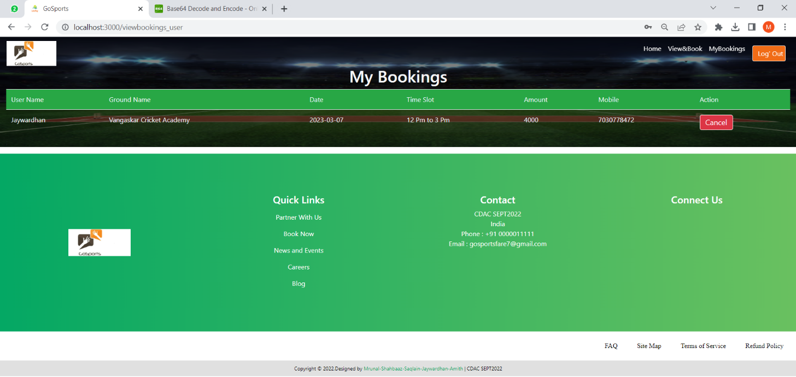

**9. CONCLUSION AND FUTURE SCOPE**

Ground Booking System provides platform to get connected with owners and customers efficiently.

Our System provides a very user-friendly platform where customers can easily Book the grounds

As per their need and time required. They can also cancel the bookings if they want to cancel the bookings.

Many sports venues are opened for free. But because the usage of venues can't be known good, people often encounter that students of athletics are in the class or there is no place for sports when go to the venues directly.

So an online booking system for sports venues is necessary. The ground booking system should provide humanized interface and complete functions. .